TMT/Rakesh Takur/S0744/2026 10-04-2026

To,

Rakesh Thakur,

Mobile: +916351712532

Dear sir,
Sub :- Supply of 20MT FOUR PILLER TYPE HYDRAULIC PRESS.
This is reference to your enquiry for the hydraulic press; we offer our least possible price as under.
Four Pillar Press:
1) Tonnage : 20 MT.

S No | Description of the unit | Offer
1. | Four Piller Type Hydraulic Press with capacity 30  Ton with Power pack of 7.5 HP motor and with power pack  Tank 100 lts  Yuken vane pump 16 lpm  Piston pump 4.0 lpm  Pressure gauge 1 No  Level indicator 1 No  Section filter 1 No  Return line filter 1 No  Section strainer 1 no  Manifold block 1 no  Pressure control valve 1 no  Solenoid operated direction control valve 1 no s  Pipes and fittings.  Bell housing 1 no  Pressure gauge 0-250 kg 1 no  Flexible houses 2 no’s  Nylon gear coupling 1 no | Rs 2,60,000/-  (Rupees Two Lakhs Sixty Thousand only)

SPECIFICATIONS FOR THE HYDRAULIC PRESS MACHINE WITH 20MT

1. Tonnage : 20 M.T.

2. Clearance between Housings : 450mm

3. Daylight : 250 mm

4. Ram stroke. : 150 M.M.

5. Open height. : 450 M.M.

6. Closed height. : 300 M.M.
Ram speeds.

a) Approach. : 12 M.M. per Sec.

b) Pressing. : 2 M.M. per Sec.

c) Return. : 20 M.M. per Sec.

9. Motor capacity. : 7.5 H.P. (Crompton)

10. Bed size. : 750 x 550 M.M.

12. Cost of Machine. : Rs.2,60,000/-+ Taxes.

13. Mode of payment. : As per the quotation.

14. Delivery. : As per the quotation.

GENERAL TERMS & CONDITIONS:

- Price quoted per unit ex-work. Hyderabad.
- Following charges are additional to your account.
- Sales Tax : 18% GST
- Packing charge : As actual to be borne by you.
- Insurance : As actual to be borne by you.
- Payment : 50% advance along with order balance before delivery but after inspection at our works.
- Delivery : With 50% advance 1 month
- Validity : One month from the date of submission.
- Inspection : Inspection at our works prior to dispatch.
- Warranty : The machine is warranted for a period of 12 months from the date of dispatch against any manufacturing defects/ faulty material or bad workmanship of any part or component but not against any kind of abnormal or improper use of machine. Defective part or component will be replaced or repaired free of cost. Electrical components are outside the scope of this warranty.
- Commissioning : Erection & commissioning done by you, but required technical support & guidance provide by us at additional cost.

NOTE:
- Oil is not in scope of our supply.
- Raw material for trial is to be arranged by you at your cost.

We are sure you will find our offer in line with your requirements. For further clarifications if any, please contact T. Sivaramakrishna, 9849207176 / 9246221106. Email: techno9246221106@gmail.com, md@technomachinetools.in

Thanking you and assuring you of our best services.

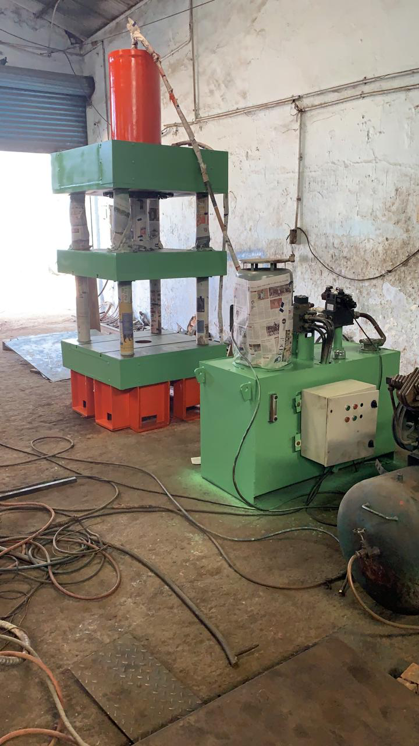

For TECHNO MACHINE TOOLS
(T. SIVARAMAKRISHNA)

